Total Hip Replacement
Recovery Programme — Day 0 to 6 Months
A structured, NICE-aligned rehabilitation pathway
How to use this programme
- This pathway follows NICE guideline NG157 (Joint replacement (primary): hip, knee and shoulder) and standard UK arthroplasty rehabilitation practice.
- It is designed to be supervised by a registered physiotherapist and tailored to you — your starting point, other health conditions and surgeon's instructions always take priority.
- Progress is criterion-based, not calendar-based: move on when you meet the goals of a phase, not simply when the dates arrive.
- Keep moving little and often. Pain is your guide — work into discomfort, never into sharp or worsening pain.

The evidence behind this plan
NICE recommends that rehabilitation begins on the day of surgery if possible, and no later than 24 hours afterwards, because early mobilisation shortens hospital stays and reduces complications. Most people are in hospital for one to three days. For uncomplicated recoveries, self-directed rehabilitation supported by a physiotherapist is the first-line approach; supervised outpatient sessions are added when progress stalls or function remains limited.
Full recovery from a total hip replacement typically takes 6 to 12 months, though most people are walking comfortably and back to everyday activities well before then.
Safety essentials from day one
- Blood-clot prevention (VTE): follow your prescribed prophylaxis, do ankle pumps hourly while resting, and keep mobilising. Seek urgent help for calf pain/swelling or breathlessness.
- Wound care: keep the wound clean and dry; report increasing redness, heat, discharge or fever.
- Hip precautions: unless your surgeon says otherwise, for the first 6 weeks avoid bending the hip past 90°, crossing the operated leg past the midline, and twisting on the operated leg.
- When to call: uncontrolled pain, a fall, the leg giving way, new numbness, or any wound or chest concern.

The recovery pathway, phase by phase
Each phase lists its goals, the activity and exercise to focus on, and the milestones that show you are ready to progress. Exercises are described generically — your physiotherapist will set repetitions, sets and progressions for you.
Timeframe | Goals | Activity & exercise | Milestones & cautions
Day 0 (day of surgery) | - Wake, breathe well, begin moving safely  - Protect the new hip | - Deep breathing & hourly ankle pumps  - Sit on edge of bed; first stand and steps with a frame, supervised  - Static quads & glute squeezes | - Mobilised within 24 h (NICE)  - Safe transfer bed↔chair with help
Day 1 – discharge (usually day 1–3) | - Independent, safe transfers & short walks  - Manage stairs if needed for home | - Walk further with frame/crutches  - Stair practice if you have steps at home  - Hip flexion (to 90°), abduction, extension within precautions | - Walk independently with aid  - On/off bed, chair, toilet safely  - Competent with home exercise plan
Week 1–2 (early home) | - Settle at home; build walking tolerance  - Control swelling & pain | - Short, frequent walks on level ground — build distance daily  - Continue core hip exercises 2–3×/day  - Elevate & ice for swelling | - Walking comfortably indoors  - Reducing reliance on stronger painkillers
Week 2–3 | - Increase confidence & distance  - Begin light daily tasks | - Progress to one crutch indoors (opposite hand)  - Half squats, heel raises holding support  - Scar massage once healed | - Managing light household tasks  - Walking outdoors with aid
Week 4–6 | - Wean walking aids  - Restore a normal walking pattern | - Outpatient physio review  - Progress balance & standing hip work  - Static bike (seat high, no resistance) if available | - 1 stick or none indoors  - Outpatient review attended  - Often cleared to drive if emergency-stop safe (check insurer)
Week 6–8 | - Independent mobility without aids  - Return to sedentary work | - Single-leg balance, step-ups/downs, bridging, clamshells  - Pool exercise once wound fully healed (no breaststroke yet) | - Walking unaided indoors & outdoors  - Hip precautions usually lifted (confirm with surgeon)  - Back to desk-based work
3–6 months | - Restore strength, endurance & function  - Return to low-impact sport & hobbies | - Progressive strengthening  - Golf, cycling, doubles tennis, dancing, gardening  - Light physical work | - Stairs normally  - Most swelling resolved  - Near-full daily function
6 months + | - Full activity except high-impact sport  - Long-term joint care | - Maintain strength & general fitness  - Avoid running/jumping unless advised | - Back to full daily activities  - Residual muscle strength continues to improve toward 12 months

Illustrated exercise library
Start with the foundation exercises and add the progressions as your physiotherapist advises. Quality matters more than quantity — slow, controlled movement with good technique. The arrow shows the direction of movement.

Foundation (Day 0 onward)
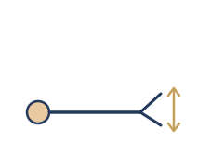 | Ankle pumps  Vigorous foot and ankle movement, hourly while resting, to keep blood moving and prevent clots.
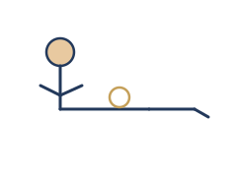 | Static quadriceps  Tighten the thigh and press the back of the knee down. Hold 5 seconds, relax.
 | Heel slides / hip flexion  Slide the heel towards you, bending the hip to no more than 90° within precautions. Slide back.
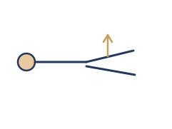 | Hip abduction  Lying or standing, take the leg out to the side keeping toes pointing forward. Return slowly.

Progression (Week 2–6)
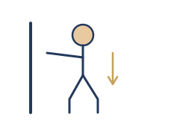 | Half squats  Hold a solid support. Bend both knees to a comfortable depth, then return upright. Repeat 10×.
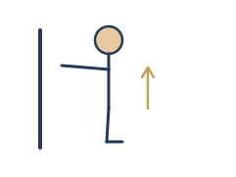 | Heel raises  Holding support, rise up onto your toes and lower with control. Repeat 10×.
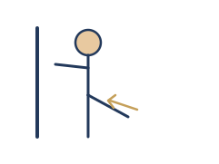 | Standing hip extension  Take the operated leg back without leaning forward. Hold a moment, return. Repeat 10×.

Strength & balance (Week 6+)
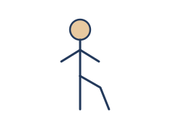 | Single-leg balance  Stand on the operated leg, lift the other behind you. Build to 30 seconds; progress by letting go of support.
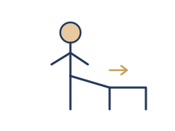 | Step-ups & step-downs  Lead with the operated leg onto a low step, then control the way down. Keep the movement smooth.
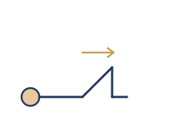 | Bridging  Lying with knees bent, lift the hips level with knees and shoulders. Hold a slow count of 10.
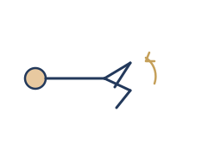 | Clamshells  On your side, knees bent, open the top knee like a clam without rolling the hips back. Repeat 10×.

Milestone checklist
Use this as a simple progress tracker. Tick each milestone when you can do it comfortably and safely.
Milestone | Achieved (date)
Mobilised and transferring safely within 24 hours of surgery
Walking independently with a frame or crutches
Managing stairs safely (if needed at home)
Competent and confident with the home exercise plan
Walking outdoors with one stick or crutch
Outpatient physiotherapy review attended (around week 6)
Walking unaided indoors and outdoors
Hip precautions lifted by surgeon (around 6 weeks)
Cleared and confident to drive
Returned to low-impact sport / hobbies (3–6 months)

Tracking your outcome
We track your recovery with the Oxford Hip Score (OHS) and a 0–10 pain and confidence rating at baseline, 6 weeks and 3 months. Rising scores confirm you are on track; a plateau or fall prompts a review.
Seek medical advice promptly if you notice
- Calf pain, tenderness or swelling, or sudden breathlessness or chest pain (possible clot).
- Spreading wound redness, heat, discharge, or a temperature/fever (possible infection).
- A sudden change in leg length, a 'clunk', or the hip giving way (possible dislocation).
- Pain that is severe, worsening, or not controlled by your prescribed medication.
- A fall, especially with new inability to bear weight.
This programme is educational and supports — but does not replace — the advice of your surgical team and treating physiotherapist. Always follow your surgeon's specific instructions where they differ from this general pathway.

